**Voice Over Self-Driving Car**

**Abstract:**

Deployment of the Artificial Intelligence (AI) in the daily life will show a new way to future, the complex task will become easy. One of such evolution of AI technology is the creation of the Self-Driving cars. But according the statistics, there are some cases where the Self-Driving cars has killed people due to the failure in the prediction or hardware problem. So, to overcome those kind of situations the AI models should be accurate and also humans should take a part. For example, where there are some people in a self-driving car and the is car about to meet with an accident or there might be any fault in the hardware of the computer and it lost control over the car then the humans in the car should be able to instruct the car using voice commands to overcome that situation. This paper deals with the usage of human voice commands against the self-driving car for the human safety. There are two Convolutional Neural Network (CNN) models involved as the advancement of Computer Vision (CV) these days has grown up beyond imagination. The Self-Driving car CNN model was trained using the Asphalt-8 game data and the Voice command prediction CNN model was trained with 3 different persons (1-Kid, 1-Man, 1-Woman) voices. The accuracy of both the CNN models were 99% and were tested on the same game where they have produced the best results.

**Keywords:** CNN, Deep Learning, Voice Commands, Game, Self-Driving, Autonomous Vehicle.

**Introduction:**

According to a survey in traffic accidents, there are more than 150,000 fatalities caused each year in India. That’s about 400 fatalities a day and far higher than developed auto markets like the US, which in 2016 logged about 40,000. Nearly 55% of these involve 4 wheel vehicles or buses. The idea of a self-driving car is an effort to minimize the accidents caused by careless and violent driving of 4 wheelers [1]. But there are some of the accidents that were also caused by Self-Driving cars. To overcome those kind of situations the proposed methodology will be used and it uses CV to work.

Computer Vision (CV) is one of the area of AI where the usage of image data will be high for the feature extraction from those images. And due to its accuracy and easy usage many new innovations are rising and the people are expecting more. Many papers were published in that field, especially in related to Deep Learning (DL) and CNN. The CNN algorithm is exploited in various fields to get the accurate results like image processing, video analysis, and much more [2]. Research and development in the ﬁeld of CV and more precisely CV using DL lead to many discoveries and practical applications in diﬀerent domains. And thus the automotive industry and the development of fully autonomous vehicles became easy by using CV. In parallel with the development of the Self-Driving cars for the human transportation, the development of various automotive platforms like delivery vehicles, robotic vehicles used in industries for the transportation of goods from one place to another is the current trend [3]. In the same way, CNN is also used in the human voice classification where the human voice signals are taken as the input and converted into images to feed to the CNN and the output will be the classification of the human voice. In keeping all the advantages of the CV by using CNN the proposed methodology is built.

This paper consists of the following topics: The methodology which is to build the Self-Driving car by using the Asphalt-8 game data is discussed, along with that the layers and the building of the CNN model is also mentioned. The building of the Voice recognition and classification model is also mentioned. The combination of the both the model and their deployment in the game for the safe driving of the Self-Driving car is also discussed. And the results of the models along with the conclusions & future work is in the last section of the paper.

**Literature Review:**

Eadhunath et Al. [1] has published a paper on a Self-Driving Car using Convolutional Neural Networks by testing it on the prototype model. The advantages are they have added GPS location system to monitor the route and also to navigation. They have added some other sensors to the car for the better working.

In the paper published by Brilian et Al. [2], they have used pre-trained YOLOv1 model, road lane detector and based on the observations the steering angle can be controlled automatically. Their proposed method is suitable for highways but not for city or dirt roads. They have used many filters to achieve good accuracy.

Jelena et Al. [3] have proposed a novel machine learning model named a J-Net. Their model is a light architecture which has less complexity and very less latency. Due to the problems in the other approaches mentioned in their paper, they have created J-Net. For 10 successful laps it’s latency is around 24ms with 44 frames per second. Due to the usage of this model the autonomous vehicular model can be embedded with less cost, low-power hardware and size.

Truong-Dong et Al. [4] mentioned their paper by proposing a model that has two phases, one is to predict the angle of steering and the other is for the road lane detection, traffic signal identification and navigation. They have mentioned that their method was tested on a RC car using Raspberry Pi and various other sensors. They have even mentioned about the study of their proposed model that has installed on the RC car on the various experimental tracks and various traffic signals placed on the track.

Wael Farag [5] has published a paper where the concept of the paper is helpful to the autonomous vehicle or self-driving car. The main theme of the paper is building an CNN based classifier called “WAF-LeNet”. The concept of the paper is the identification of the traffic signal using the proposed CNN model. German Traffic dataset was used for the training of the model and the model has produced over 96.5% of accuracy on the test dataset and about 100% accuracy on the robust data.

Vishal et Al. [6] has published a chapter in a book named as Convolutional Neural Networks for Raw Speech recognition. They have covered the methodology for the conversion of the voice to images and recognition of the voice through the converted images by using the word image database. They have used waves generated by voice signals which is more useful for the identical and is most commonly using for the speech recognition or mood recognition. The musical notes generation or identifications also done using the voice signals.

Sanguk et Al. [7] has mentioned about the theoretical implications as well as practical implications about the design of the autonomous vehicle voice agents (AVVA). Based on the gender of the people in the self-driving car the response to the conversation made by the virtual assistant will effect. They have mentioned about the stereotypical expectation of the social role (informative male AVVA and social female AVVA). The main purpose of the paper is making an effective virtual assistant or AVVA that can be installed inside the self-driving cars.

**Problem Statement:**

The main problem is that the self-driven cars that are in the present world are not 100% accurate in all the times. The accuracy will depend on various factors like road condition, GPS signals, weather conditions, and many more. A small error produced by the model will lead to the terrible effects to the people present in the car. To overcome this situation, the person who sits in the vehicle should be always alert and should know how to drive that vehicle. But there might be some passengers who might not able to drive that particular type of vehicle, then there will be a problem and it can lead to very uncertain conditions. The present self-driven cars are coming with no driving compartment and only a screen is present inside the vehicle to give the instructions and navigations to the passengers. For instance, let us suppose that the self-driving car is a taxi and there is no driver compartment and if the machine fails due to some technical problem then the people inside the car can get into any unpleasant situation.

To overcome all the above problems, we propose a methodology which can be used effectively in all kind of situations and also can be installed in all the self-driven cars for the passenger safety. The solution is represented with the process model and various other results of the model in the proposed methodology statement phase in this paper.

**Proposed Methodology:**

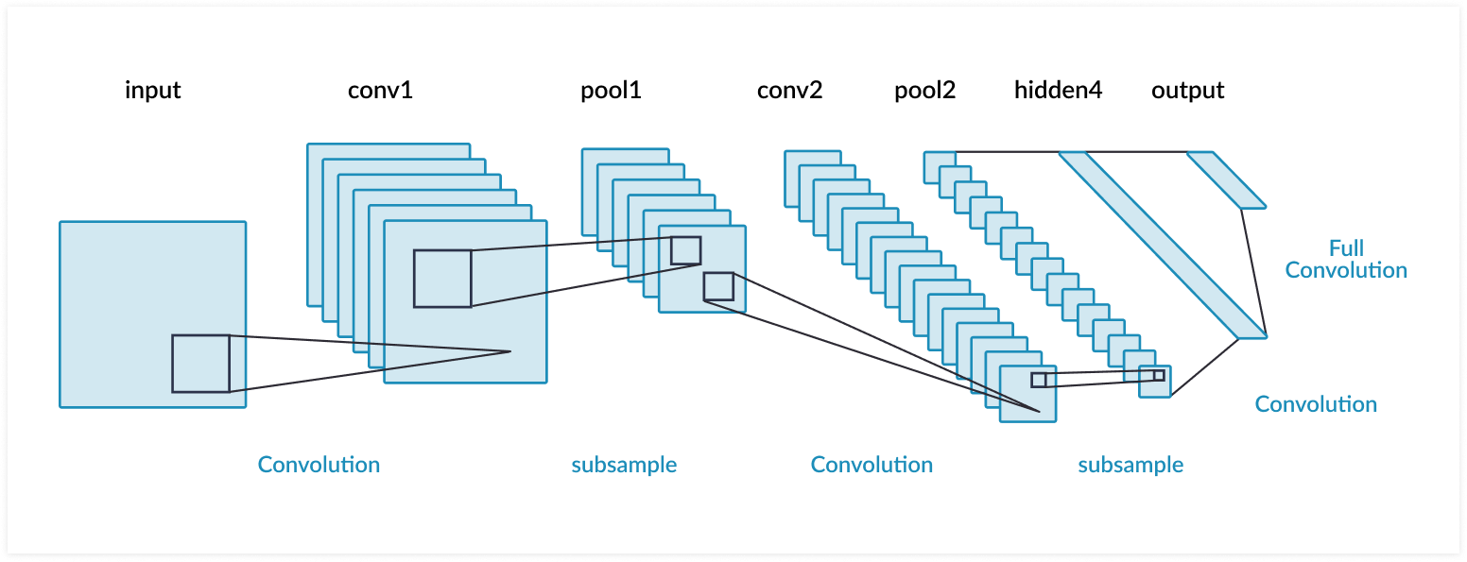

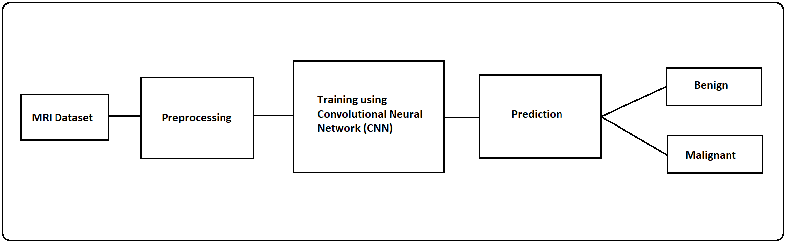

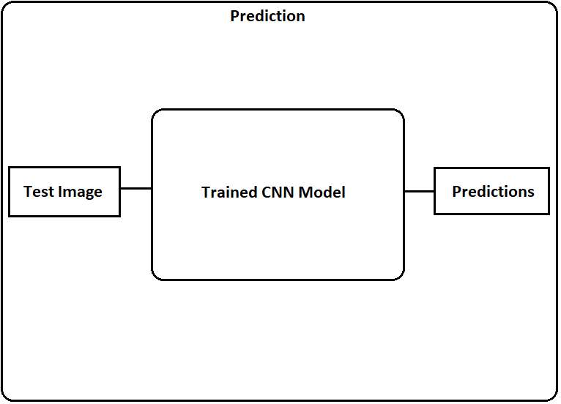

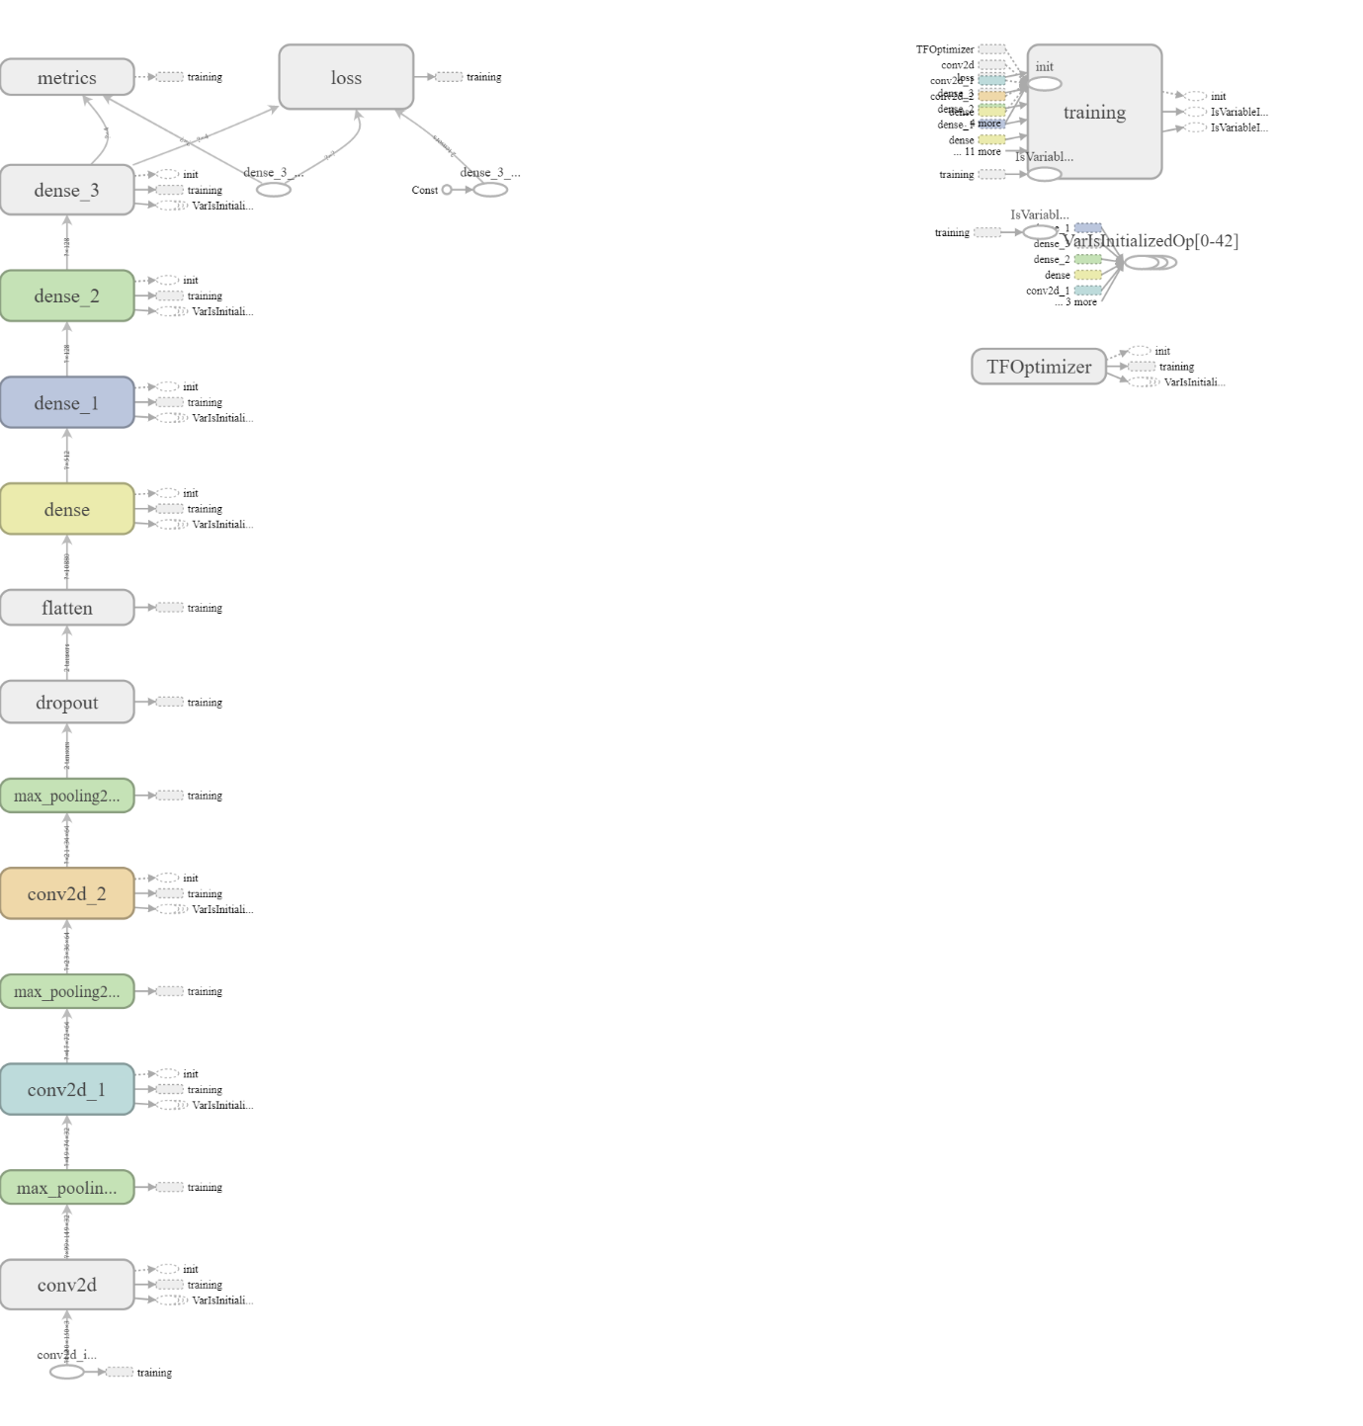



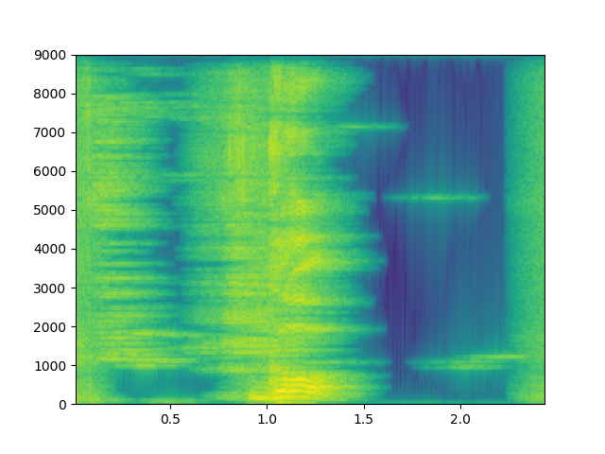

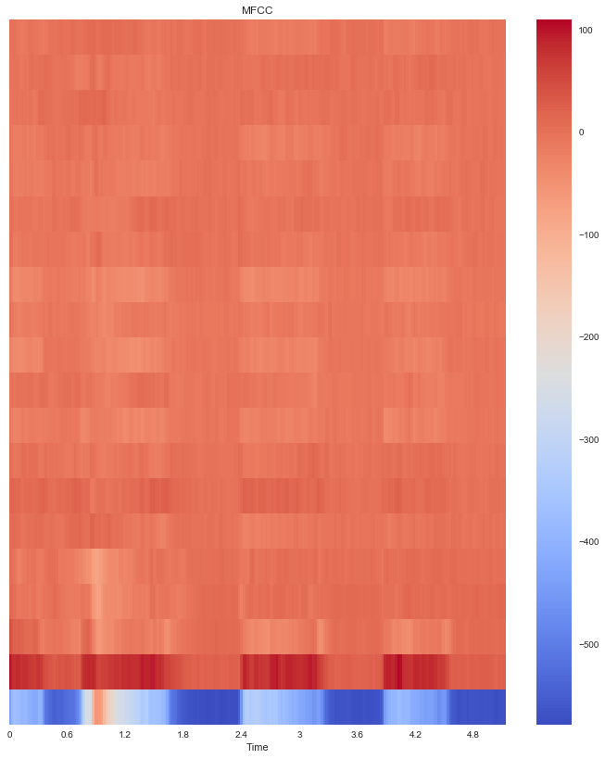

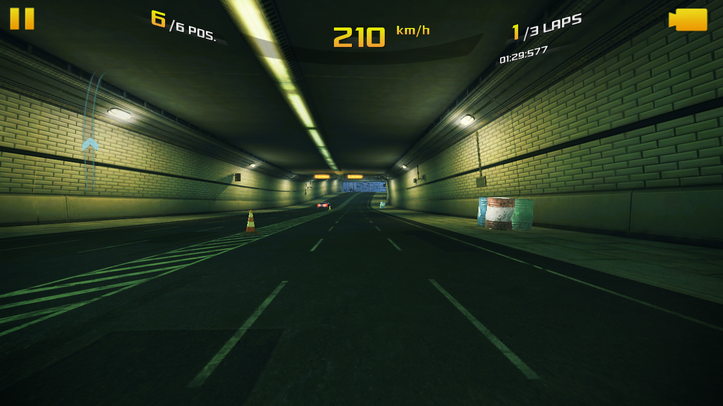

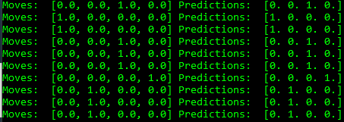

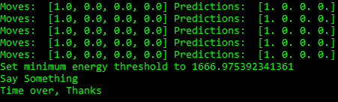

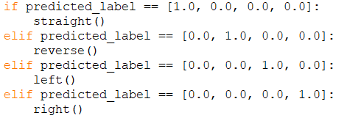

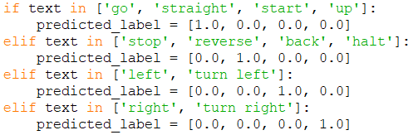

So, in this paper we propose a voice over vehicular control model that will help the passengers in that vehicle to instruct the vehicle what to do in those kind of situations. The main advantage of this model is that the passengers need not to have any driving experience, they can use the voice commands like “Go Straight”, “Turn Left”, “Turn Right”, “Stop”, and “Reverse” to control the vehicle in that kind of situtaions.

Build the CNN and Process the Model:

Pre-Processing the Data:

1. Primary step is to take all the images at once and put them in a folder.

2. A blank array is defined to store the images and respective classes which are multi-dimensional.

3. Read the images using Open CV, which converts the images into numerical arrays.

4. A NumPy file is been saved for every image by combining the [image_array, class].

5. Now, NumPy file is used to read all the images which exists along with their respective class. 6. The images are in the order of audio files. This may impact the efficiency of the model, hence the NumPy file is shuffled to make the confused over an order, but not original data.

7. This NumPy file which is shuffled is saved as another file. The same process is conducted for the train dataset and test dataset too.

Building the Neural Network:

1. The Numpy file which is created above is imported and size adjustment is done from multidimensional array to single dimensional array.

2. A sequential network of 5 layers is built with 3 layers as the hidden layers.

3. First layer is known as the flatten layer, this layer used to resize the data.

4. Second layer, which is first hidden layer, is with neural network nodes and rectified linear activation function.

5. Third layer, which is second hidden layer, is built with 512 neural network nodes and relu activation function.

6. Fourth layer (third hidden layer) with 128 nodes neural network and relu as activation function.

7. The last layer is the layer with the same number of nodes as the classes that are available and activation function is soft max (normalized exponential function to normalizes k real numbers into a probability distribution consisting of K probabilities).

8. The model needs to be compiled using Adam Optimizer.

9. The loss in the network can be found with sparse categorical cross entropy.

10. The constructed model is trained with 300 epochs as a result it produces 100% accuracy.

**Results and Discussion:**

Abc

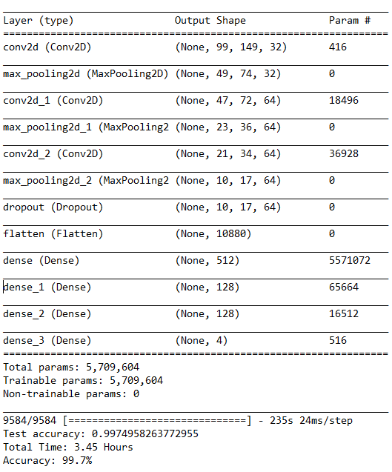

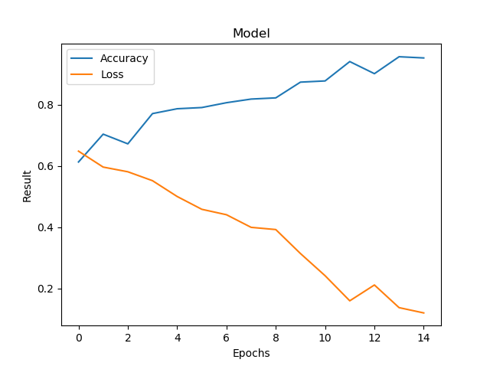

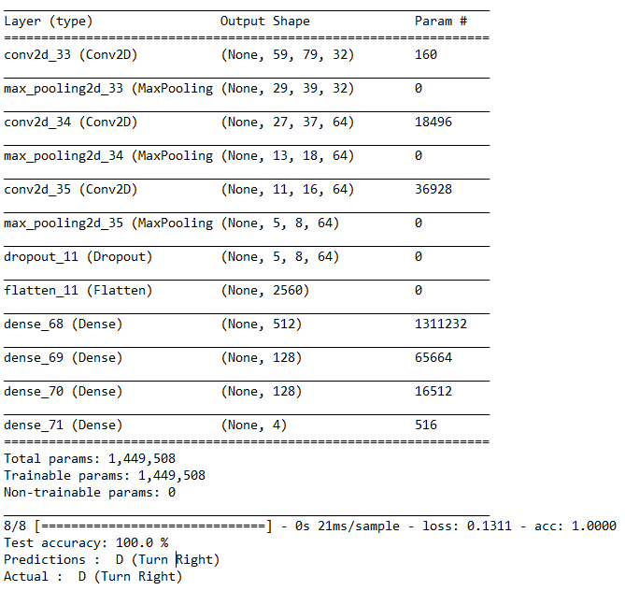

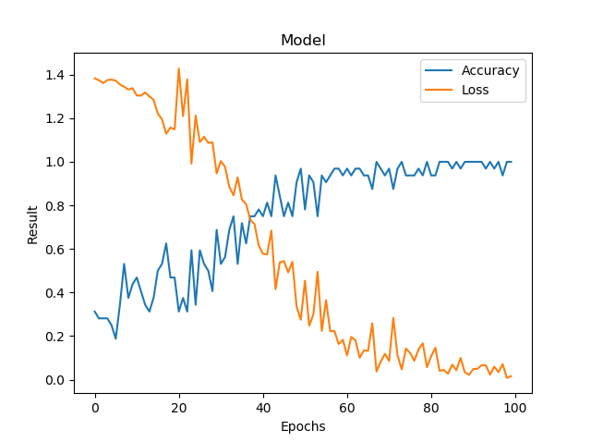

**Conclusion and Future Work:**

Abc

**References:**

[1]. Eadhunath V, Amir Suhail, Jayant Waghmare, Rishab Mishra, Prof. K. U. Jadhav, “Self-Driving Car using Convolutional Neural Network and Road Lane Detector”, International Journal of Engineering Research & Technology (May - 2019), Volume – 8, Issue – 5, pp. 951-954.

[2]. Brilian Tafjira Nugraha, Shun-Feng Su, Fahmizal, “Towards Self-Driving Car using Convolutional Neural Network and Road Lane Detector”, International Conference on Automation, Cognitive Science, Optics, Micro Electro-Mechanical System, and Information Technology (ICACOMIT), October 23, 2017, Jakarta, Indonesia, pp. 65-70.

[3]. Jelena Kocic , Nenad Jovicˇic and Vujo Drndarevic, “An End-to-End Deep Neural Network for Autonomous Driving Designed for Embedded Automotive Platforms”, Sensors 2019, 19, 2064.

[4]. Truong-Dong Do, Minh-Thien Duong, Quoc-Vu Dang and My-Ha Le, “Real-Time Self-Driving Car Navigation Using Deep Neural Network”, 2018 4th International Conference on Green Technology and Sustainable Development (GTSD), pp. 7-13.

[5]. Wael Farag, “Recognition of trafﬁc signs by convolutional neural nets for self-driving vehicles”, International Journal of Knowledge-based and Intelligent Engineering Systems, Vol. 22, (2018), pp. 205–214.

[6]. Vishal Passricha and Rajesh Kumar Aggarwal, “Convolutional Neural Networks for Raw Speech Recognition”, From Natural to Artificial Intelligence, IntechOpen, Chapter 2, 2018, 10.5772/intechopen.80026

[7]. Sanguk Lee, Rabindra Ratan and Taiwoo Park, “The Voice Makes the Car: Enhancing Autonomous Vehicle Perceptions and Adoption Intention through Voice Agent Gender and Style”, Multimodal Technol. Interact. 2019, 3, 20.